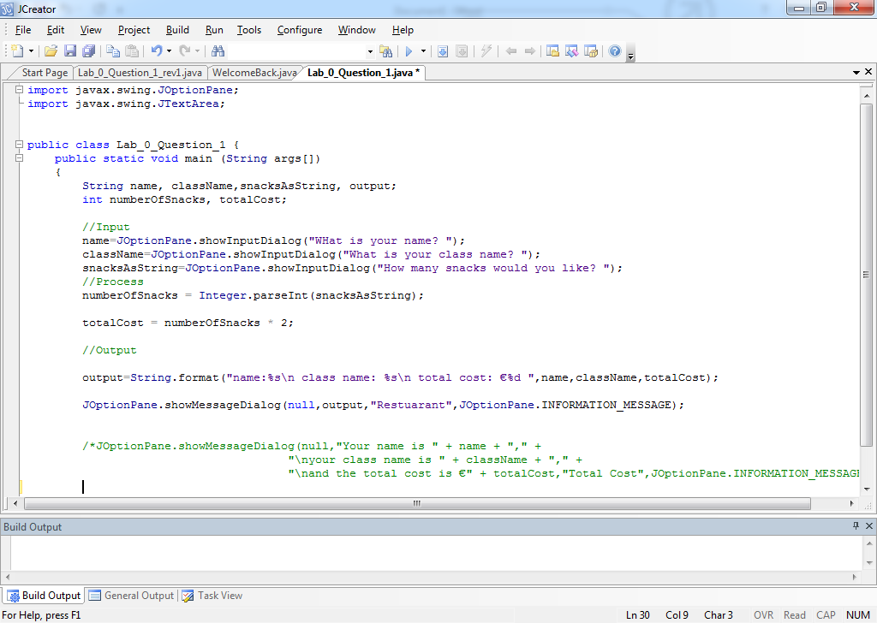

Assigning Values

Local Variables

Method Header

Class Header

Import statements

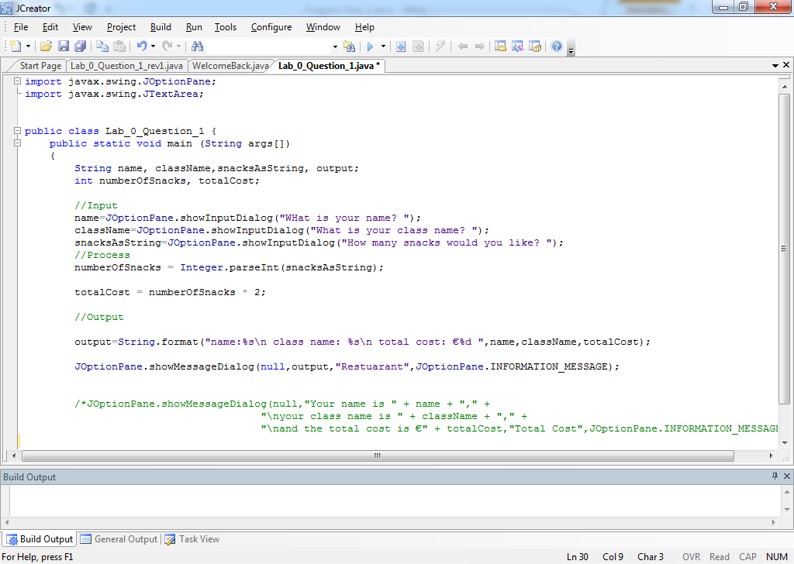

import java.util.\*;

Object

class WelcomeBack {

public static void main(String []args){

Scanner in = new Scanner(System.in);

System.out.println("welcome");

System.out.println("what is youe name?");

String name=in.next();

System.out.println("welcome "+name);

}//end main